**Workshop 1**

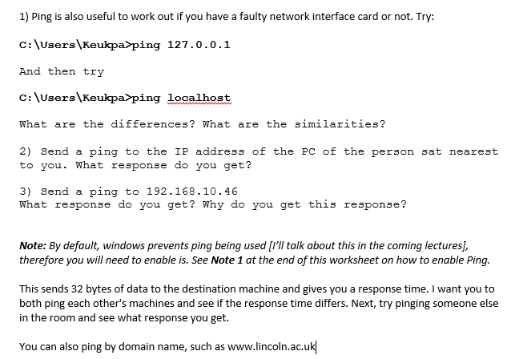

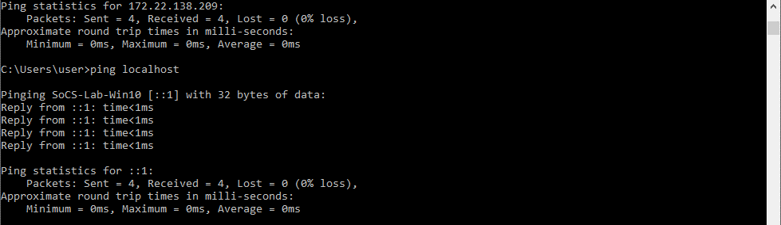1.1.

Pinged the location with 32 bytes 4 times, both connected every time. The IP address Ping was done internally but the localhost ping was done internally

1.2.

1.3.

2.1.

2.2.

2.3.